H.T No
Regulations:
A17


Sreenidhi Institute of Science and Technology
(An Autonomous Institution)
Code No: 6A201 Date: 05-Jan-2019 (FN)

B.Tech I-Year II-Semester End External Examination, Dec-2018/Jan-2019 (Supplementary)
CIRCUITS AND NETWORKS – I (EEE)

Time: 3 Hours Max.Marks:75

Note: a) No additional answer sheets will be provided.
b) All sub-parts of a question must be answered at one place only, otherwise it will not be valued.
c) Missing data can be assumed suitably.

Part - A Max.Marks:25

Answer all QUESTIONS.
1. | State Ohm’s law and write its limitations. | [3M]
2. | Derive an expression for equivalent resistance of ‘n’ resistances connected in series. | [3M]
3. | Define the terms (i) tree (ii) co-tree . | [3M]
4. | Define cut set. | [3M]
5. | Define magnetic flux density. | [3M]
6. | State Faraday’s laws of electromagnetic induction. | [2M]
7. | Define average value of an alternating quantity. | [2M]
8. | What is quality factor. Explain its significance. | [2M]
9. | State reciprocity theorem. | [2M]
10. | What is the condition for maximum power transfer in an electric network. | [2M]
Part – B Max.Marks:50
ANSWER ANY FIVE QUESTIONS. EACH QUESTION CARRIES 10 MARKS.
11. | a) | Explain the classification of network elements. | [4M]
 | b) | Find the equivalent resistance between the terminals X and Y in Figure 1.  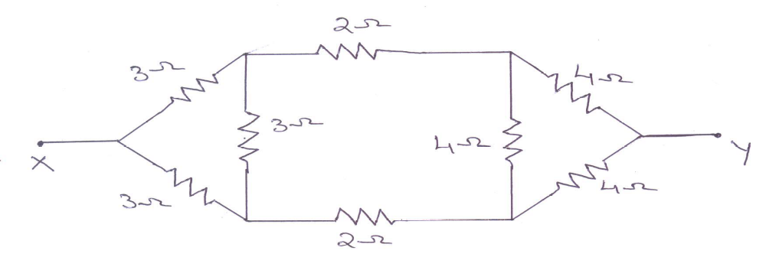  Figure 1 | [6M]
12. | a) | Explain the procedure for obtaining fundamental cut – set matrix of a given network. | [5M]
 | b) | Write the basic cut – set schedule for the network shown in Figure 2 by considering 10Ω resistor branches as tree branches.  Figure 2  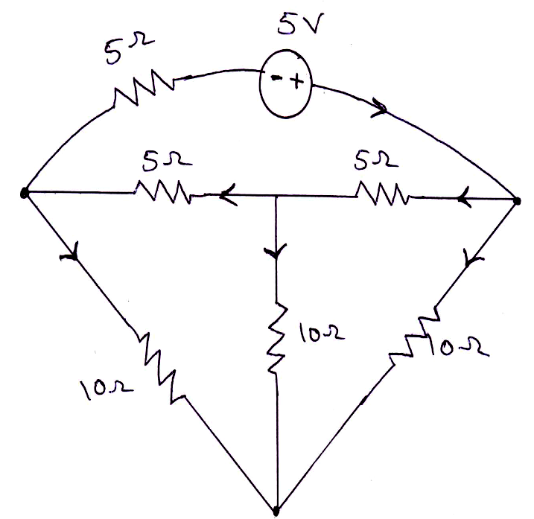 | [5M]
13. | a) | Compare electric and magnetic circuits clearly stating the similarities and dissimilarities between them. | [4M]
 | b) | An iron ring has a mean diameter of 25cm and a cross sectional area of 4 cm². It is wound with a coil of 1200 turns, carrying a current of 2A. If an air gap of 1.5mm width is cut in the ring, determine the flux density in the ring. The relative permeability of iron is 800. | [6M]
14. | a) | Determine the average value of a full wave rectified sine wave. | [5M]
 | b) | An R – L series circuit allows a current i(t) = 10 sin(314t - 60⁰)A to flow from an alternating voltage source v(t) = 200 sin 314t V. Find the circuit parameters. | [5M]
15. | a) | Show that the locus of current in an R – C circuit with variable R is a semicircle. Find the radius and centre of the circle. | [5M]
 | b) | Find the value of L in the circuit shown in Figure 3 such that the circuit resonates at ω = 100 rad/sec.  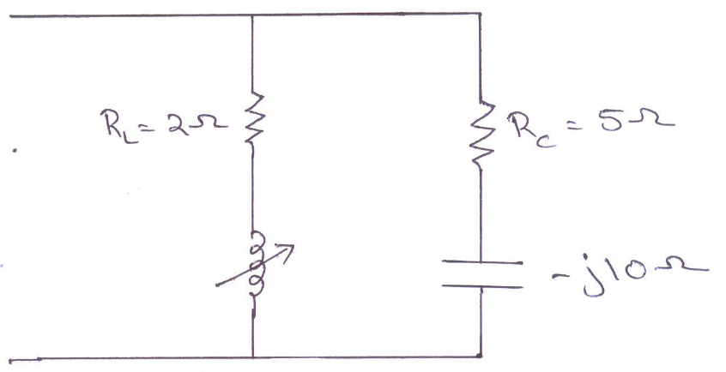  Figure 3 | [5M]
16. | a) | State and explain Norton’s theorem. | [4M]
 | b) | Find the value of R_{L} in circuit shown in Figure 4 such that maximum power is delivered to the load. Also find the maximum power.  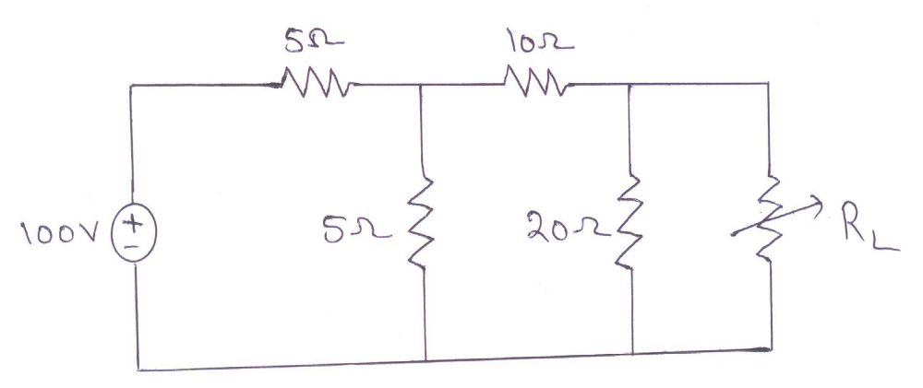  Figure 4 | [6M]
17. | a) | Calculate the currents in each branch for the network shown in Figure 5 by using nodal analysis.  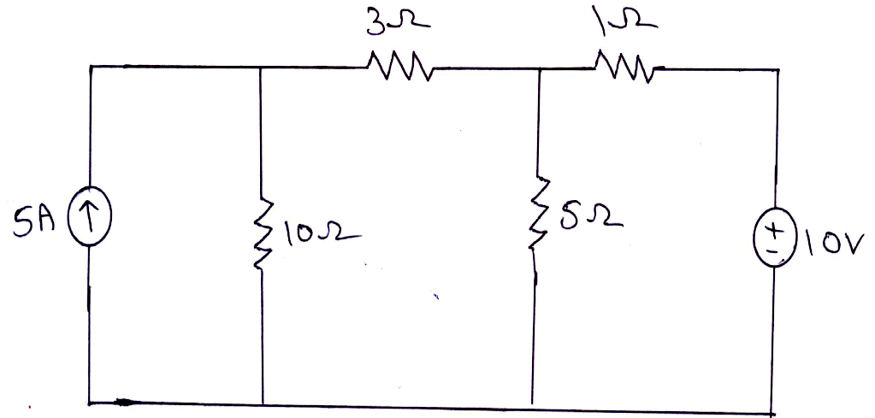  Figure 5 | [5M]
 | b) | Two similar coils connected in series give a total inductance of 600mH and when one of the coils is reversed, the total inductance is 300mH. Determine the mutual inductance between the coils and coefficient of coupling. | [5M]
18. | a) | Show that the average power consumed by a pure capacitor is zero. | [5M]
 | b) | Using Millman’s theorem, find the current through 10Ω resistor shown in Figure 6.  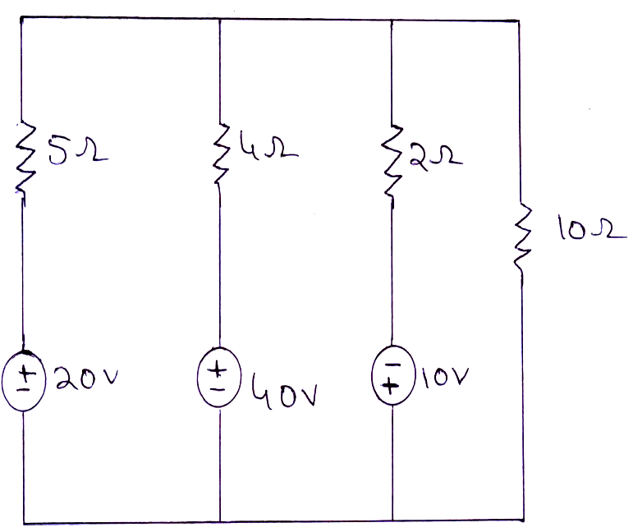  Figure 6 | [5M]

-- 00 -- 00 –

